

**STATISTICAL SURVEY ON AWARENESS AND IMPACT OF NATIONAL EDUCATION POLICY -2020**

**INSTITUTE OF MATHEMATICAL SCIENCE AND COMPUTER APPLICATION**

**BUNDELKHAND UNIVESITY**

**JHANSI**



**BUNDELKHAND UNIVERSITY JHANSI**

**DEPARTMENT OF**

**INSTITUTE OF MATHEMATICAL SCIENCE**

**AND COMPUTER APPLICATIONS**

**SESSION : 2022 -2023**



**PROJECT FILE**

**STATISTICAL SURVEY ON AWARENESS AND IMPACT OF**

**NATIONAL EDUCATION POLICY -2020**

(Partial fulfillment of minor project)

**Under the Supervision of**

**Dr. ANJALI SAXENA**

**Assistant professor**

**PREPARED BY**

**NAME- SUNEEL KUMAR**

**ROLL NO.- 201181134059**

**COURSE- B.Sc (Hons.)(M/S/C)**

**SEMESTER - Vth  semester**

**TABLE OF CONTENTS**

Page no.

Certificate 4

Certificate of approval 5

Declaration 6

Acknowledgement 7

List of chapters 8

List of Table 9

*List of Figure……………………………………………………………………..10*

**CERTIFICATE**

This is to certify that **SUNEEL KUMAR** (Roll No.- 201181134059) has carried out the research work presented in this dissertation entitled **“Statistical Survey on awareness and impact of National Education policy-2020 ”** for the award of the degree of **B.Sc(Hons.) (Mathematics /Statistics / computer Science )** from Institute of Mathematical science and computer applications, Bundelkhand University, Jhansi under my supervision.

Signature of Guide:

**(Dr. ANJALI SAXENA)**

(Assistant professor) Date:

(Institute of Mathematical Science

and Computer Application,

Bundelkhand University, Jhansi)

**CERTIFICATE OF APPROVAL**

The proposed project report entitled **“ STATISTICAL SURVEY ON AWARENESS AND IMPACT OF NATIONAL EDUCATION POLICY 2020”** being submitted by **“ SUNEEL KUMAR**” has been examined by us and its hereby approved for the award of the degree “**B.Sc (Hons.) (Mathematics/ Statistics/Computer science)”**,for which it has been submitted.

It is understood that by this approval the undersigned do not necessarily endorse or approve any statement made , opinion expressed or conclusion drawn therein , but approve the survey report only for the purpose for which it has been submitted.

( Internal Examiner) ( External Examiner )

Date - Date -

.

**DECLARATION**

I am student of **B.Sc (Hons.) (Mathematics/ Statistics/ Computer science)** session 2022-2023, **BUNDELKHAND UNIVERSITY JHANSI (U.P.),** hereby declare that the survey report entitled “**STATISTICAL SURVEY ON AWARENESS AND IMPACT OF NATIONAL EDUCATION POLICY-2020** ”,over science stream student, is the outcome of my own work and that, to the best of my knowledge and belief, it contains no material previously written by another person nor material which to a substain a extent has been accepted for the award of any other diploma or degree of the university or other institute of learning , where due acknowledgement has been made in the text.

Signature of student

Place: Jhansi Suneel kumar

Date:

**ACKNOWLEDGEMENTS**

Every successful work is not completed without the help and support of the people around us. A success is shared by not an individual but in fact by the people who constantly help him and guide him in his work. Through this I want to express my gratitude towards all those who have directly or indirectly contributed in my journey.

It is my esteemed pleasure to present the survey report on **“Statistical survey for accessing the impact of National Education Policy-2020”.**

I express my deep gratitude to my guide , **“Dr. Anjali Saxena”** ,Assistant professor of department of mathematical science and computer application, who gave me the inspiration to pursue the survey and guided me in this endeavor. He has been a constant source of motivation and encouragement for me. I thank him for all the initiative and zeal he filled us with throughout the project work.

Last but not the least I am very thankful to my teacher “ **Mr. Prabhat Karmarkar**” without their support at various stages , this project wouldn’t have materialized.

I am really thankful to them. Secondly I would also like to thank my group members who helped me a lot in finishing this project within the limited time.

I am making this project not only for marks but to also increase my knowledge.

THANKS AGAIN TO ALL WHO HELPED ME

# 

# List of Chapters:-

**CHAPTER TOPICS PAGE NO.**

CHAPTER 1 INTRODUCTION 11-13

Introduction to NEP

Salient features of policy

CHAPTER 2 OBJECTIVE AND PURPOSE 14-16

Objective

Aim and purpose

Comparison of new NEP with existing NEP

CHAPTER 3 REVIEW OF LITERATURE 17

CHAPTER 4 METHODOLOGY & QUESTIONNAIRE 18-21

Methodology

Google form view

Questionnaire for the survey

CHAPTER 5 DATA COLLECTION AND CLEANING 22-25

Data collection

Cleaning of raw data

List of variables used

CHAPTER 6 STATISTICAL TEST AND HYPOTHESIS 26

Fisher’s exact test

Hypothesis

CHAPTER 7 DATA TABULATION AND INTERPRETATION 27-56

Data tabulation and graphs

* 1. Testing of Hypothesis
  2. Summary report

CHAPTER 8 RESULT AND COCLUSION 57-59

* 1. Result
  2. Amendments provided by students
  3. Conclusion
  4. Reference

# List of Tables-

# Table no. Title Page

# List of Figures

**Figure Title Page**

**CHAPTER – 1**

**INTRODUCTION**

**INTRODUCTION TO THE NEP-**

The National Policy on Education (NPE) is a policy formulated by the Government of India to promote education amongst India's people. The policy covers elementary education to colleges in both rural and urban India. The first NPE was promulgated by the Government of India by Prime Minister Indira Gandhi in 1968, the second by Prime Minister Rajiv Gandhi in 1986, and the third by Prime Minister Narendra Modi in 2020.

The National Education Policy 2020 (NEP 2020), which was approved by the Union Cabinet of India on 29 July 2020, outlines the vision of India's new education system. The new policy replaces the previous National Policy on Education, 1986. The policy is a comprehensive framework for elementary education to higher education as well as vocational training in both rural and urban India. The policy aims to transform India's education system by 2021. The language policy in NEP is a broad guideline and advisory in nature; and it is up to the states, institutions, and schools to decide on the implementation. The NEP 2020 enacts numerous changes in India's education policy. It aims to increase state expenditure on education from around 4% to 6% of the GDP as soon as possible.

In January 2015, a committee under former Cabinet Secretary T. S. R. Subramanian started the consultation process for the New Education Policy. Based on the committee report, in June 2017, the draft NEP was submitted in 2019 by a panel led by former Indian Space Research Organisation (ISRO) chief Krishnaswamy Kasturirangan. The Draft New Education Policy (DNEP) 2019, was later released by Ministry of Human Resource Development, followed by a number of public consultations. The Draft NEP had 484 pages. The Ministry undertook a rigorous consultation process in formulating the draft policy: "Over two lakh suggestions from 2.5 lakh gram panchayats, 6,600 blocks, 6,000 Urban Local Bodies (ULBs), 676 districts were received." The vision of the National Education Policy is: “National Education Policy 2020 envisions an India-centric education system that contributes directly to transforming our nation sustainably into an equitable and vibrant knowledge society by providing high-quality education to all.”

Quality higher education must aim to develop individuals who are excellent, thoughtful, well-rounded, and creative. It must enable a person to study one or more specialized areas of interest at an in-depth level and develop character, ethical and constitutional values, intellectual curiosity, scientific temper, creativity, service spirit, and the skills of the 21st century across a range of fields, including sciences, social sciences, the arts, humanities, languages, personal,

technological the vocational subjects. The new education policy brings some fundamental changes to the current system, and the key highlights are multidisciplinary universities and colleges, with at least one in or near every district, revamping student curricula, pedagogy, evaluation, and support for enhanced student experience, establishing a National Research Foundation to support excellent peer-reviewed work and effectively seed study at universities and colleges.

The main problems faced by the Indian higher education system includes enforced separation of qualifications, early specialization and student streaming into restricted research areas, less focus on research at most universities and schools, and lack of competitive peer-reviewed academic research funding and large affiliated universities leading to low levels of undergraduate education.

Institutional restructuring and consolidation aim to end the fragmentation of higher education by transforming higher education institutions into large multidisciplinary, creating well- rounded and innovative individuals, and transforming other countries educationally and economically, increasing the gross enrolment ratio in higher education, including vocational training, from 26.3% (2018) to 50% by 2035.

Holistic and multidisciplinary education should strive in an integrated way to improve all human capacities-mental, cultural, social, physical, emotional, and moral. In the long term, such a comprehensive education shall be the method for all undergraduate programs, including those in medical, technical, and vocational disciplines. Optimal learning environments and support for students offer a holistic approach including adequate curriculum, interactive pedagogy, consistent formative assessment, and adequate support for students.

**SALIENT FEATURES OF THE POLICY-**

A number of action points/activities for implementation in school education as well as higher education are mentioned in the National Education Policy 2020. Details of the salient features of NEP 2020 are as follows-

* Ensuring Universal Access at All Levels of schooling from pre-primary school to Grade 12;
* Ensuring quality early childhood care and education for all children between 3-6 years;
* New Curricular and Pedagogical Structure (5+3+3+4);
* No hard separations between arts and sciences, between curricular and extra-curricular activities, between    vocational and academic streams;
* Establishing National Mission on Foundational Literacy and Numeracy;
* Emphasis on promoting multilingualism and Indian languages; The medium of instruction until at least Grade 5, but preferably till Grade 8 and beyond, will be the home language/mother tongue/local language/regional language.
* Assessment reforms - Board Exams on up to two occasions during any given school year, one main examination and one for improvement, if desired;
* Setting up of a new National Assessment Centre, PARAKH (Performance Assessment, Review, and Analysis of Knowledge for Holistic Development);
* Equitable and inclusive education - Special emphasis given on Socially and Economically Disadvantaged  Groups (SEDGs);
* A separate Gender Inclusion fund and Special Education Zones for disadvantaged regions and groups;
* Robust and transparent processes for recruitment of teachers and merit based performance;
* Ensuring availability of all resources through school complexes and clusters;
* (xiii) Setting up of State School Standards Authority (SSSA);
* (xiv) Exposure of vocational education in school and higher education system;
* Increasing GER in higher education to 50%;
* (xvi) Holistic and Multidisciplinary Education with multiple entry/exit options;
* NTA to offer Common Entrance Exam for Admission to HEIs;
* Establishment of Academic Bank of Credit;
* (xix) Setting up of Multidisciplinary Education and Research Universities (MERUs);
* Setting up of National Research Foundation (NRF);
* ‘Light but Tight’ regulation;
* Single overarching umbrella body for promotion of higher education sector including teacher education and excluding medical and legal education- the Higher Education Commission of India (HECI)-with independent bodies for standard setting- the General Education Council; funding-Higher Education Grants Council (HEGC); accreditation- National Accreditation Council (NAC); and regulation- National Higher Education Regulatory Council (NHERC);
* Expansion of open and distance learning to increase Gross Enrolment Ratio (GER).
* Internationalization of Education
* Professional Education will be an integral part of the higher education system. Stand-alone technical universities, health science universities, legal and agricultural universities, or institutions in these or other fields, will aim to become multi-disciplinary institutions.
* Teacher Education - 4-year integrated stage-specific, subject- specific Bachelor of Education
* Establishing a National Mission for Mentoring.
* Creation of an autonomous body, the National Educational Technology Forum (NETF) to provide a platform for the free exchange of ideas on the use of technology to enhance learning, assessment, planning, administration. Appropriate integration of technology into all levels of education.
* Achieving 100% youth and adult literacy.
* Multiple mechanisms with checks and balances will combat and stop the commercialization of higher  education.
* All education institutions will be held to similar standards of audit and disclosure as a ‘not for profit’ entity.
* The Centre and the States will work together to increase the public investment in Education sector to   reach 6% of GDP at the earliest.
* Strengthening of the Central Advisory Board of Education to ensure coordination to bring overall  focus on quality education.

**CHAPTER – 2**

**OBJECTIVE AND COMPARISON**

**Objectives –**

The National Education policy 2020 is mainly focused on upgrading the education structure prevalent from 1980s and combating the need of the hour to step up with advancement in technology in 21st century. The National Education policy 2020 has many initiatives to improve the quality and the broadness of the education system in India. The objectives of this survey on National Education Policy 2020 are:

* To make a set of population aware of new education Policy (NEP 2020)
* To gauge opinion of education related professionals on National Education Policy 2020.
* To identify new approach to modify higher education in NEP, 2020.
* To highlights and overview the policies of the newly accepted higher education system (NEP 2020 To compare National Education Policy 2020 with the currently adopted policy in India
* To identify the innovations in new national higher education policy 2020.
* To predict the implications of NEP 2020 on the Indian higher education system.
* To discuss the merits of Higher Education Policies of NEP 2020.
* Suggestions for further improvements for the effective implementation of NEP 2020 to realize its goal.

**AIM -**

* NEP, 2020 aim to increase the GER to 100% in preschool to secondary level by 2030 whereas GER in Higher Education including vocational education from 26.3% (2018) to 50% by 2035.
* Awareness on the previous and new amendments in National Education Policy.

**PURPOSE -**

The purpose of the National Education Policy is to develop students’ in critical thinking skills, scientific temper, and imagination, along with instilling values like empathy, courage, and resilience. This paper endeavors to introduce you to the key aspects of the novel National Education Policy (here on referred to as the NEP), discuss its pros and cons, and offer solutions and recommendations to potential problems observed.

**Comparison of new NEP 2020 with Existing NEP :**

The 1986 National Education policy focussed on the modernization of the education sector using information technology. More attention was given to restructuring teacher education, early childhood care, women’s empowerment, and adult literacy. It also proposed that the autonomy of universities and colleges will improve the quality of education services. But NEP 1986 failed to improve the quality of education in terms of creating graduates with employability skills and failed to generate research output in terms of patents and scholarly publications. To compensate for the failure of previous NEPs, NEP 2020 has proposals of a liberal education to support multidisciplinary and cross-disciplinary education and research in under-graduation and post graduation levels. Table 2 compares the improvements of some of the features of National Education policy 2020 with its previous National Education policy 1986.

**Table 2.1**

Comparison of National Education policy 1986 & National Education policy 2020

|  |  |  |
| --- | --- | --- |
| **Sr. No.** | **NEP 1986** | **NEP 2020** |
| **1** | The role of education is the all-round development of students. | Objective is to provide Multidisciplinary & interdisciplinary liberal education. |
| **2** | Common education structure of 10 (5+3+2)+2+3+2 is followed. | Common education structure of 5+3+3+4+4+1 is suggested. |
| **3** | The first preliminary education starts at 6th year of a child as Primary school level. | The first preliminary education starts at 3rd year of a child as a Foundation stage. Four years Secondary education stage is designated by clubbing Two years higher secondary level and two years pre-university levels. Exams are suggested at the school level except for Board level exams at 10th and 12th . |
| **4** | Two years higher secondary level and two years pre-university levels were separately considered and both had board exams. Four years Secondary education stage is designated by clubbing | Four years Secondary education stage is designated by clubbing Two years higher secondary level and two years pre-university levels. Exams are suggested at the school level except for Board level exams at 10th and 12th . |
| **5** | Two years of higher secondary level, students choose specialization areas and subjects like Science subjects or Commerce subjects or Arts subjects | Four years Secondary education stage contains common subjects and elective subjects. Choice is based on liberal education policy |
| **6** | All undergraduate and postgraduate admissions are based on the entrance exam conducted at the college level or state level except NITs & Medical Colleges. | All undergraduate and postgraduate admissions of public HEIs are based on National Testing Agency (NTA) scores conducted by the national level. |
| **7** | Undergraduate programmes are for three to four years. | Undergraduate programmes are of four years with a provision to exit after one year with a diploma, after two years with an advanced diploma, after three years with a pass degree, and after four years with project based degree. |
| **8** | Postgraduate education is of two years with specialization focus | Postgraduate education is of one to two years with more specialization & research focus. |
| **9** | Most of the Colleges in HEIs are affiliated to state universities and had no autonomy in curriculum and evaluation. | All HEIs including colleges are autonomous and there will be no affiliated colleges to state universities and autonomy in deciding curriculum and evaluation. |
| **10** | Examination is independent of teaching. All examination and evaluation is affiliating university controlled. There is a little role of teaching faculty members in evaluating the students directly | Examination is a part of a continuous evaluation system. Faculty members who are teaching a subject are responsible for evaluation and examinations are departmental affairs. |
| **11** | Teaching-learning method mainly focuses on classroom training and fieldwork. | Teaching-learning method mainly focuses on classroom training, fieldwork, and research projects. |
| **12** | In the higher education system, the expected student-faculty ratio is 20:1. | In higher education system, the expected student faculty ratio is 30:1. |
| **13** | In HEIs faculty members are considered as facilitators of educating students to make them competent. | In HEIs faculty members are considered as collaborators and guide of educating students to make them as innovators & creative thinkers |
| **14** | Students have the freedom to choose subjects across their area of study | Students have the freedom to choose subjects outside and across their area of study. |
| **15** | Lateral entry is offered in some programmes. But no Multiple entries and Multiple exit facilities are available in under graduation including medical and paramedical courses. | Multiple entries and Multiple exit facilities are available in under graduation including medical and paramedical courses. |
| **16** | Undergraduate programmes of 3 years to 4 years depending on the type of the programme. | All undergraduate programmes are of 4 years with, in some cases, exit at 3 years is possible with a degree certificate. |
| **17** | Both single discipline and multidiscipline colleges are promoted. | Only multidisciplinary colleges and universities are promoted. All single discipline colleges have to convert themselves autonomous multidisciplinary colleges or will be closed and converted into monuments or public libraries. |
| **18** | No foreign universities are allowed to function directly in India | About 100 top ranked foreign universities will be allowed to function in India to compete with Indian universities |

**CHAPTER – 3 REVIEW OF LITERATURE**

* 4.1. National Education Policy (1968) In India, the Social Work Education was commenced in the year 1936, with the establishment of Tata Institute of Social Sciences. In the post-independence reforms, education was given prominence. In the year 1966, first education policy was announced. This was aimed at “Radical Restructuring” and aimed at equal education opportunities in order to achieve complete education with national integration. This policy aimed at promoting the significance of education among the Indians, primary education and secondary education is given priority and the establishment of schools in both rural and urban areas.
* 4.2. National Education Policy (1986) The NEP of 1986 aimed promoting minority education, education for women equality, education of SC, ST and backward sections and emphasis was more given towards equal education opportunities and education to all sections of the society. This new education policy has given highest priority in solving the problem of school dropouts and adopts an array of meticulously formulated strategies based on micro planning and applied at the grass root levels of all over the country. A national mission was launched for the achievement of this NEP 1986. Based on the literature review of education policy of 1966 emphasized on equal education to all and the NEP of 1986 gave prominence to women education and promoting minority education and reducing dropouts from the schools.

**CHAPTER – 4**

**METHODOLOGY AND QUESTIONNAIRE**

**Methodology**

The methodology consists of a conceptual discussion on highlighting the gist of the national educational policy framework, highlighting various sections of the policy of NEP 2020 and comparing it with currently adopted education policy.

An online survey is conducted over Google Form in Bundelkhand university. Response of each participant is collected using linked survey and responses were automatically generated and recorded. The survey is equally responded by students contributing almost equally. The survey was disconnected in one month time. The questionnaire includes fifteen questions covering basic changes, awareness and new implementation to be incorporated and replacing the old scheme and syllabus according to the need of the hour and was applied on a sample consisting of 128 participants which in turn reflects major population of science stream students. The period of application of the questionnaire is December 20th 2022 to 28th january,2023.

A total of 128 participants completed the questionnaire data on "New Education Policy” was collected between December 20th, 2022 to January 28th, 2023 using an online questionnaire spread throughout the internet.

The purpose of this study is to spread awareness regarding NEP, 2020 policy. A survey questionnaire is administered uniformly on a sample of 128 participants mainly students of science side. Participants are assured that their information would be used only for research purpose. There were no right and wrong responses.

After collecting the data, the percentage of each response was calculated.

When the all responses is collected we follow the procedure to get the result-

* First of all we enter all data in a excel sheet which is formed as raw data.
* In second step we clean the data by removing unwanted variables like name , email etc.
* When the data is cleaned we replace the statements with variables which are strings, numeric.
* After it we analyze data and apply exact and get the p value of sample.
* Then we set the hypothesis to find out the association between the variables

**GOOGLE FORM VIEW**

**FIG- 4.1&4.2 (GOOGLE FORM QUESTIONNAIRE)**

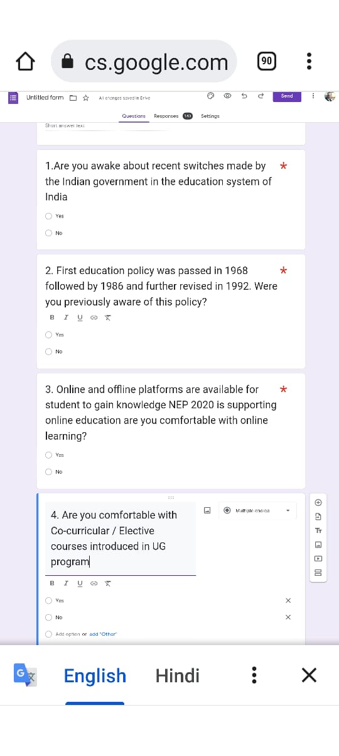

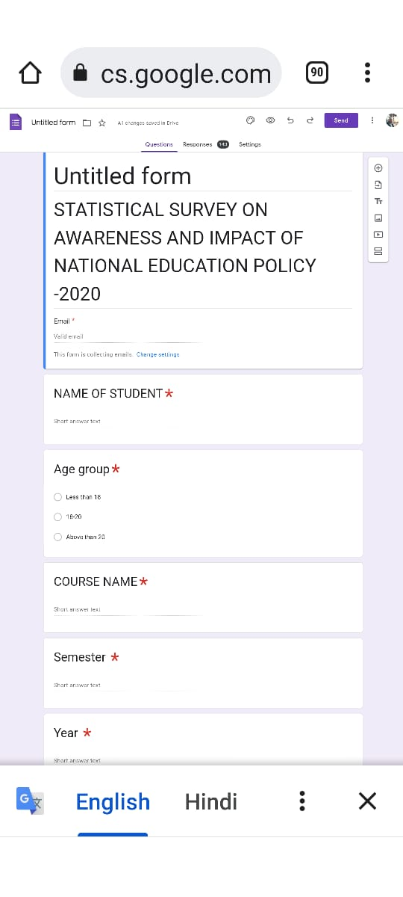

**QUESTIONNAIRE FOR THE SURVEY**



**“STATISTICAL SURVEY ON AWARENESS AND IMPACT OF NATIONAL EDUCATION POLICY – 2020”**

**Student information-**

Name- Age -

Course name- Year/Semester- _

1. Are you awake about recent switches made by the Indian government in the education system of India.
2. YES
3. NO
4. First education policy was passed in 1968 followed by 1986 and further revised in 1992. Were you previously aware of this policy?
5. YES
6. NO
7. Online and offline platforms are available for students to gain knowledge. NEP-2020 is supporting online education. Are you comfortable with online learning?
8. YES
9. NO

4 Are you satisfied with the elective papers/ Internship courses/ Field Projects introduced in PG program?

i. YES

ii NO

5 Are you satisfied with Co-curricular / Elective courses introduced in UG program

1. YES
2. NO

6 Do you agree with the policy statement that multiple entry/exit option in 4 years bachelors as a certificate in one year, diploma in 2 years, degree in 3 years while research in 4th year is beneficial for students

1. YES
2. NO

7 Do you agree with the policy statement that multiple entry/exit option in UG courses will positively affect the education and career of students?

1. YES
2. NO

8 Do you want that the method of teaching in institutions need to be reinvent?

1. YES
2. NO

9 Theoretical syllabus of course is a burden and reason of stress for students. Do you think that Reduction in the syllabus to core essentials with experimental learning and critical thinking will lessen the burden on students for gaining a higher percentage of marks and reduce mishaps due to stress of studies?

1. YES
2. NO

10 Do you think that STEAM (Science, Technology, Engineering, Art, Mathematics) is better than the previous STEM (Science , Technology, Engineering, Mathematics) model in higher education UG level?

1. YES
2. NO

11.Do you think that the concepts of elective paper/ co- curricular courses will beneficiary to you?

1. Strongly disagree
2. Agree
3. Disagree
4. Strongly agree
5. Neither agree nor disagree

12Do you think that jobs after vocational courses should be assured by the government to boost employment situation?

1. Strongly disagree
2. Agree
3. Disagree
4. Strongly agree
5. Neither agree nor disagree

13 As the Ministry of Education highlighted that the NEP policy is based on the pillars of “ access, equity, quality, affordability, accountability” and will transform India into a “vibrant knowledge Hub” Do you agree with this fact?

1. Strongly disagree
2. Agree
3. Disagree
4. Strongly agree
5. Neither agree nor disagree

14The aim of NEP- 2020 to increase the Gross Enrolment Ratio in higher education including vocational education from 26.3% (2018) to 50% by 2035. Do you think that the increment in gross enrolment ratio will help to improve the level of literacy in India?

1. Strongly disagree
2. Agree
3. Disagree
4. Strongly agree
5. Neither agree nor disagree
6. Is there any change in current reforms that you did not want?
7. Yes
8. No

**CHAPTER-5**

**DATA COLLECTION AND DATA CLEANING**

**DATA COLLECTION-**

Data is collected through the Google form explore sheet in excel-

**RAW DATA –**

**FIG-5.1**

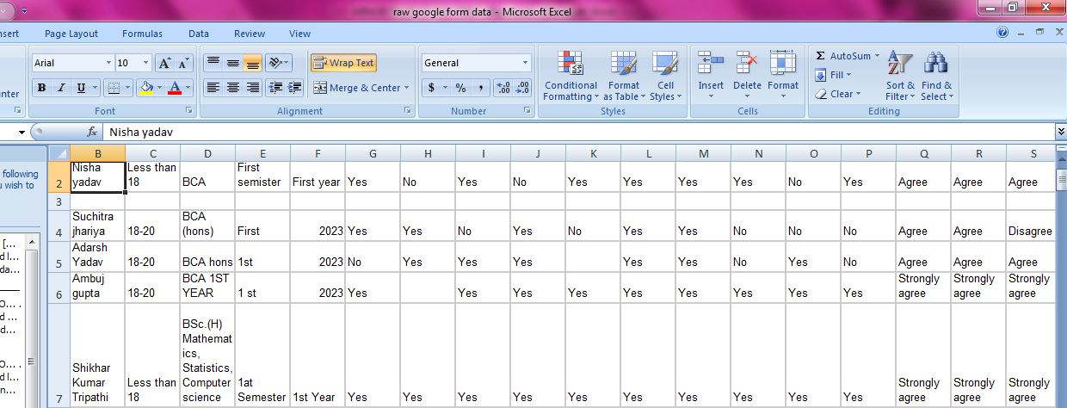

**CLEANING OF RAW DATA**

TOOLS USED FOR CLEANING-

* FILTER

**FIG-5.2**

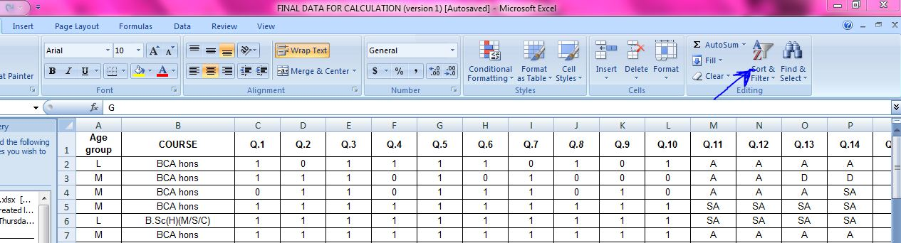

**FIG-5.3**

* FIND AND REPLACE

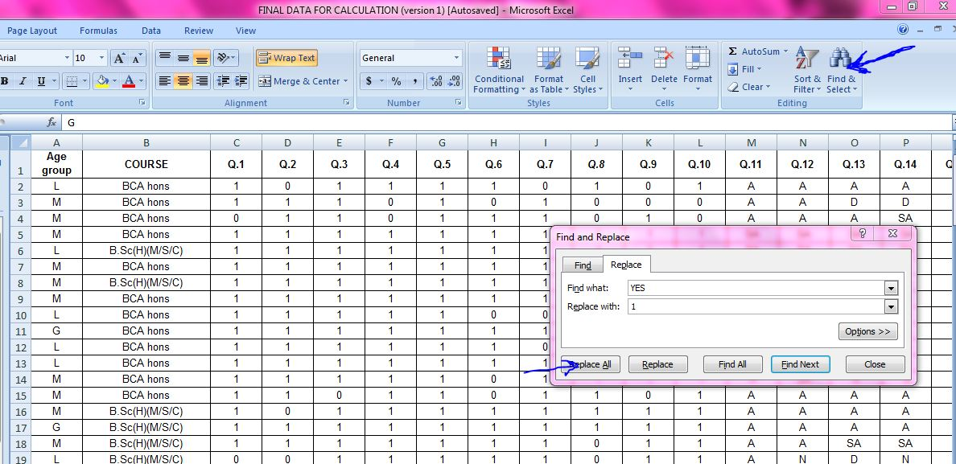

DATA UPLOADING FROM EXCEL TO SPSS-

**FIG-5.4**

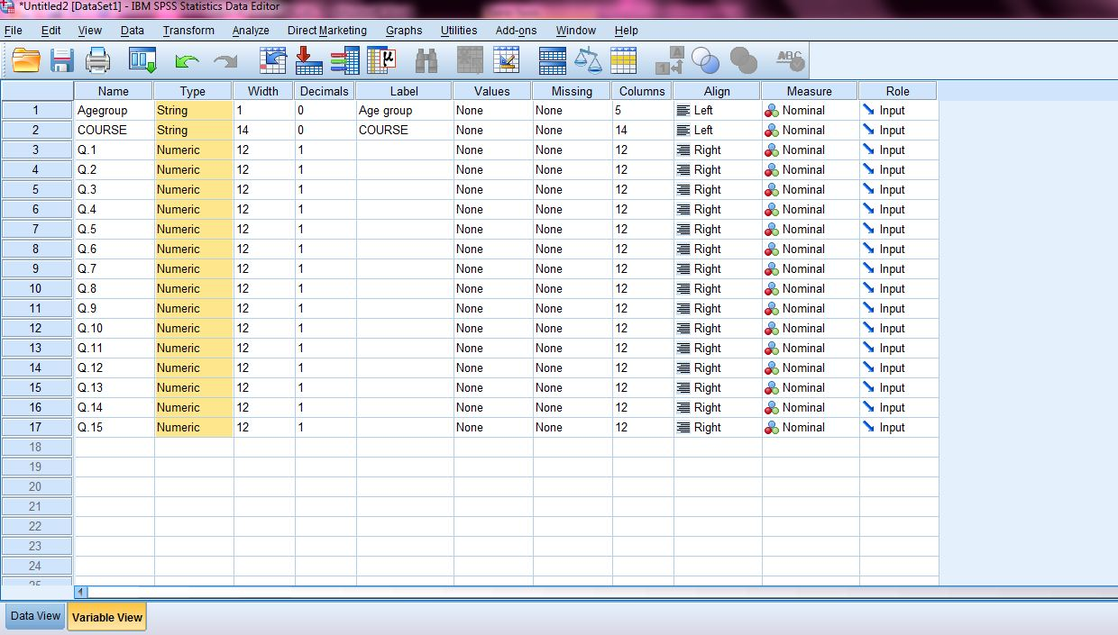

**LIST OF VARIABLES USED-**

**TABLE -5.1**

|  |  |  |
| --- | --- | --- |
| **VARIABLES** | **TYPE** | **EXPLANATION** |
| Age group | Character String L,M, N | Age of students |
| L- Less than 18 |
| M- 18-20 |
| G- Above than 20 |
| COURSE | String type | course pursued by first year students |
| Q.1 | Numeric 1,2 | Are you awake about recent switches made by the Indian government in the education system of India. |
| 1-YES, 0- NO |
| Q.2 | Numeric 1,2 | First education policy was passed in 1968 followed by 1986 and further revised in 1992. Were you previously aware of this policy? |
| 1-YES, 0- NO |
| Q.3 | Numeric 1,2 | 3. Online and offline platforms are available for students to gain knowledge. NEP-2020 is supporting online education. Are you comfortable with online learning? |
| 1-YES, 0- NO |
| Q.4 | Numeric 1,2 | Are you satisfied with the elective papers/ Internship courses/ Field Projects introduced in PG program? |
| 1-YES, 0- NO |
| Q.5 | Numeric 1,2 | Are you satisfied with Co-curricular / Elective courses introduced in UG program |
| 1-YES, 0- NO |
| Q.6 | Numeric 1,2 | Do you agree with the policy statement that multiple entry/exit option in 4 years bachelors as a certificate in one year, diploma in 2 years, degree in 3 years while research in 4th year is beneficial for students |
| 1-YES, 0- NO |
| Q.7 | Numeric 1,2 | Do you agree with the policy statement that multiple entry/exit option in UG courses will positively affect the education and career of students? |
| 1-YES, 0- NO |
| Q.8 | Numeric 1,2 | Do you want that the method of teaching in institutions need to be reinvent? |
| 1-YES, 0- NO |
| Q.9 | Numeric 1,2 | Theoretical syllabus of course is a burden and reason of stress for students. Do you think that Reduction in the syllabus to core essentials with experimental learning and critical thinking will lessen the burden on students for gaining a higher percentage of marks and reduce mishaps due to stress of studies? |
| 1-YES, 0- NO |
| Q.10 | Numeric 1,2 | Do you think that STEAM (Science, Technology, Engineering, Art, Mathematics) is better than the previous STEM (Science , Technology, Engineering, Mathematics) model in higher education UG level? |
| 1-YES, 0- NO |
| Q.11 | Character String- SA,A,SD,D,N | Do you think that the concepts of elective paper/ co- curricular courses will beneficiary to you? |
| SA-STRONGLY AGREE, A- AGREE , SD- STRONGLY DISAGREE, D- DISAGREE , N- NEITHER AGREE NOR DISAGREE |
| Q.12 | Character String- SA,A,SD,D,N | Do you think that jobs after vocational courses should be assured by the government to boost employment situation? |
| SA-STRONGLY AGREE, A- AGREE , SD- STRONGLY DISAGREE, D- DISAGREE , N- NEITHER AGREE NOR DISAGREE |
| Q.13 | Character String- SA,A,SD,D,N | As the Ministry of Education highlighted that the NEP policy is based on the pillars of “ access, equity, quality, affordability, accountability” and will transform India into a “vibrant knowledge Hub” Do you agree with this fact? |
| SA-STRONGLY AGREE, A- AGREE , SD- STRONGLY DISAGREE, D- DISAGREE , N- NEITHER AGREE NOR DISAGREE |
| Q.14 | Character String- SA,A,SD,D,N | Do you think that the increment in gross enrolment ratio will help to improve the level of literacy in India which is aimed under NEP 2020 to increase the Gross Enrolment Ratio in higher education including vocational education from 26.3% (2018) to 50% by 2035. ? |
| SA-STRONGLY AGREE, A- AGREE , SD- STRONGLY DISAGREE, D- DISAGREE , N- NEITHER AGREE NOR DISAGREE |
| Q.15 | Numeric 1,2 | Is there any amendment in current policy that you did not want? |
| 1-YES, 0- NO |

**CHAPTER – 6**

**STATISTICAL TEST AND HYPOTHESIS**

**FISHER’S EXACT TEST**

Fisher’s Exact Test of Independence is a statistical test used when you have two nominal variables and want to find out if proportions for one nominal variable are different among values of the other nominal variable. For experiments with small numbers of participants (under around 1,000), Fisher’s is more accurate than the [chi-square](https://www.statisticshowto.com/probability-and-statistics/chi-square/) test or G-test.

Unlike other statistical tests, there isn’t a formula for Fisher’s. To get a result for this test, calculate the probability of getting the observed data using the null hypothesis that the proportions are the same for both sets.

Fisher’s Exact Test is used to determine whether or not there is a significant association between two categorical variables. It is typically used as an alternative to the [Chi-Square Test of Independence](https://www.statology.org/chi-square-test-of-independence/) when one or more of the cell counts in a 2×2 table is less than 5.

SET THE HYPOTHESIS-

Fisher’s Exact Test uses the following null and alternative hypotheses:

* H0: (null hypothesis) The two variables are independent.
* H1: (alternative hypothesis) The two variables are not independent.

We check the hypothesis at 5% significance level =0.05

* H0 (n>0.05) – There is no association between both variables
* H1(n<0.05) – Both variables are associated with each other

**CHAPTER – 7**

**DATA TABULATION AND INTERPRETATION**

**[Crosstab](https://www.qualtrics.com/au/experience-management/research/cross-tabulation/)**

[Crosstab (cross-tabulation)](https://www.qualtrics.com/au/experience-management/research/cross-tabulation/) is used in [quantitative market research](https://www.qualtrics.com/au/experience-management/research/quantitative-research/) to analyse categorical data – that is, variables that are different and mutually exclusive

Data tabulation and graphs

CROSSTABS

The first table displays the number of missing cases in the dataset. We can see that there are 0 missing cases

|  |  |  |  |  |  |  |  |  |  |  |  |  |  |  |
| --- | --- | --- | --- | --- | --- | --- | --- | --- | --- | --- | --- | --- | --- | --- |
|  | |  |  | |  | |  | |  | |  | |  | |
|  | TABLE 7.1 -Case Processing Summary | | | | | | | | | | | | | | |  |
|  |  | | | Cases | | | | | | | | | | | |  |
|  | Valid | | | | Missing | | | | Total | | | |  |
|  | N | | Percent | | N | | Percent | | N | | Percent | |  |
|  | COURSE * Age group | | | 128 | | 100.0% | | 0 | | 0.0% | | 128 | | 100.0% | |  |
|  | COURSE * Q.1 | | | 128 | | 100.0% | | 0 | | 0.0% | | 128 | | 100.0% | |  |
|  | COURSE * Q.2 | | | 128 | | 100.0% | | 0 | | 0.0% | | 128 | | 100.0% | |  |
|  | COURSE * Q.3 | | | 128 | | 100.0% | | 0 | | 0.0% | | 128 | | 100.0% | |  |
|  | COURSE * Q.4 | | | 128 | | 100.0% | | 0 | | 0.0% | | 128 | | 100.0% | |  |
|  | COURSE * Q.5 | | | 128 | | 100.0% | | 0 | | 0.0% | | 128 | | 100.0% | |  |
|  | COURSE * Q.6 | | | 128 | | 100.0% | | 0 | | 0.0% | | 128 | | 100.0% | |  |
|  | COURSE * Q.7 | | | 128 | | 100.0% | | 0 | | 0.0% | | 128 | | 100.0% | |  |
|  | COURSE * Q.8 | | | 128 | | 100.0% | | 0 | | 0.0% | | 128 | | 100.0% | |  |
|  | COURSE * Q.9 | | | 128 | | 100.0% | | 0 | | 0.0% | | 128 | | 100.0% | |  |
|  | COURSE * Q.10 | | | 128 | | 100.0% | | 0 | | 0.0% | | 128 | | 100.0% | |  |
|  | COURSE * Q.11 | | | 128 | | 100.0% | | 0 | | 0.0% | | 128 | | 100.0% | |  |
|  | COURSE * Q.12 | | | 128 | | 100.0% | | 0 | | 0.0% | | 128 | | 100.0% | |  |
|  | COURSE * Q.13 | | | 128 | | 100.0% | | 0 | | 0.0% | | 128 | | 100.0% | |  |
|  | COURSE * Q.14 | | | 128 | | 100.0% | | 0 | | 0.0% | | 128 | | 100.0% | |  |
|  | COURSE * Q.15 | | | 128 | | 100.0% | | 0 | | 0.0% | | 128 | | 100.0% | |  |
|  |  | | |  | |  | |  | |  | |  | |  | |  |

* THESE TABLE SHOWS THE CROSSTABS BETWEEN INDEPENDENT AND DEPENDENT VARIABLE

**TABLE 7.2 – CLASSIFICATION OF STUDENTS ON THE BASIS OF AGE GROUP**

|  |  |
| --- | --- |
| L- Less than 18 |  |
| M- 18-20 |  |
| G- Above than 20 | |

|  |  |  |  |  |  |
| --- | --- | --- | --- | --- | --- |
| Crosstab - COURSE * Age group | | | | | |
| Count | | | | | |
|  | | Age group | | | Total |
| G | L | M |
| COURSE | B.Sc(H)(M/S/C) | 4 | 19 | 59 | 82 |
| BCA hons | 7 | 10 | 29 | 46 |
| Total | | 11 | 29 | 88 | 128 |

From the above table it is observed that most of the students belong to the age group 18-20

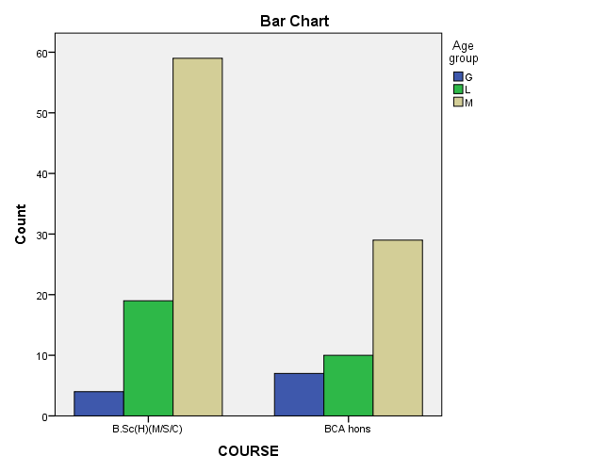

FIG-7.1 CLASSIFICATION OF STUDENTS ON THE BASIS OF AGE GROUP

* **TABLE 7.3 – RESPONSES OF STUDENTS ON Q1**

(Q1 Are you awake about recent switches made by the Indian government in the education system of India.)

|  |  |  |  |  |
| --- | --- | --- | --- | --- |
| 1-YES | | |  | |
| 0-NO | | |  | |
|  | | | | |
| **Crosstab - COURSE * Q1** | | | | | | | |
| Crosstab | | | | | | |
| Count | | | | | | |
|  | | | Q.1 | | | Total |
| .0 | | 1.0 |
| COURSE | B.Sc(H)(M/S/C) | | 12 | | 70 | 82 |
| BCA hons | | 8 | | 38 | 46 |
| Total | | | 20 | | 108 | 128 |

From above table it is clear that most of the students are aware of new education policy

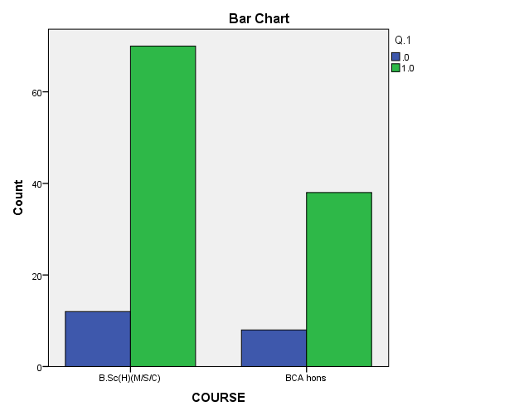

FIG-7.2 CLASSIFICATION OF STUDENTS ON THE BASIS OF RESPONSES ON Q1

**TABLE 7.4 – RESPONSES OF STUDENTS ON Q2**

(Q2 First education policy was passed in 1968 followed by 1986 and further revised in 1992. Were you previously aware of this policy?.)

|  |  |  |  |  |
| --- | --- | --- | --- | --- |
| 1-YES | | |  | |
| 0-NO | | |  | |
| **Crosstab - COURSE * Q2** | | | | | | | |
| Crosstab | | | | | | |
| Count | | | | | | |
|  | | | Q.2 | | | Total |
| .0 | | 1.0 |
| COURSE | B.Sc(H)(M/S/C) | | 34 | | 48 | 82 |
| BCA hons | | 16 | | 30 | 46 |
| Total | | | 50 | | 78 | 128 |

From above table it is observed that most of the students are aware about the previous policy.

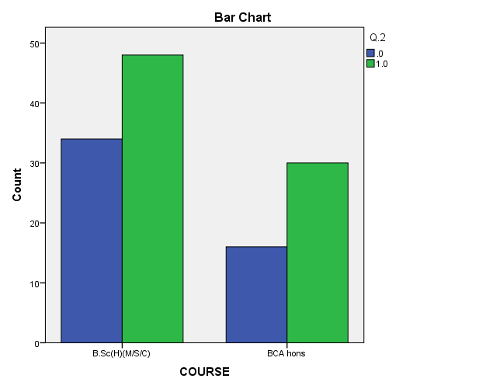

FIG-7.3 CLASSIFICATION OF STUDENTS ON THE BASIS OF RESPONSES ON Q2

**TABLE 7.5 – CLASSIFICATION OF STUDENTS ON THE BASIS OF RESPONSES ON Q3**

(Q3 Online and offline platforms are available for students to gain knowledge. NEP-2020 is supporting online education. Are you comfortable with online learning?

1-YES

0-NO

|  |  |
| --- | --- |
|  |  |
|  |  |
|  | |

|  |
| --- |
| **Crosstab - COURSE *Q3** |

|  |  |  |  |  |
| --- | --- | --- | --- | --- |
| Crosstab | | | | |
| Count | | | | |
|  | | Q.3 | | Total |
| .0 | 1.0 |
| COURSE | B.Sc(H)(M/S/C) | 13 | 69 | 82 |
| BCA hons | 8 | 38 | 46 |
| Total | | 21 | 107 | 128 |

From the above table it is observed that most of the students are In favor of Q3

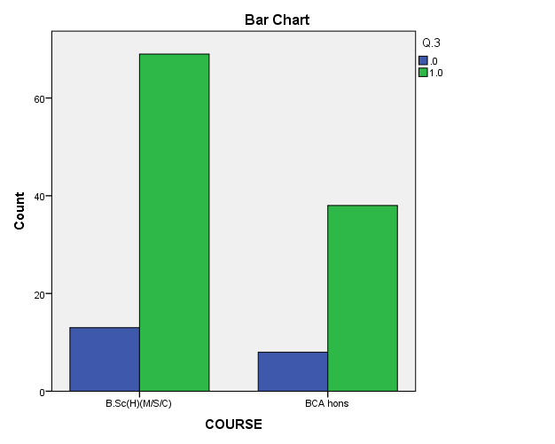

FIG7.4- CLASSIFICATION OF STUDENTS ON THE BASIS OF RESPONSES ON Q3

**TABLE 7.6 – CLASSIFICATION OF STUDENTS ON THE BASIS OF RESPONSES ON Q4**

(Q4 Are you satisfied with the elective papers/ Internship courses/ Field Projects introduced in PG program?

1-YES

0-NO

**Crosstab - COURSE * Q4**

|  |  |  |  |  |
| --- | --- | --- | --- | --- |
| Crosstab | | | | |
| Count | | | | |
|  | | Q.4 | | Total |
| .0 | 1.0 |
| COURSE | B.Sc(H)(M/S/C) | 12 | 70 | 82 |
| BCA hons | 7 | 39 | 46 |
| Total | | 19 | 109 | 128 |

From the above table it is observed that most of the students are In favor of Q4

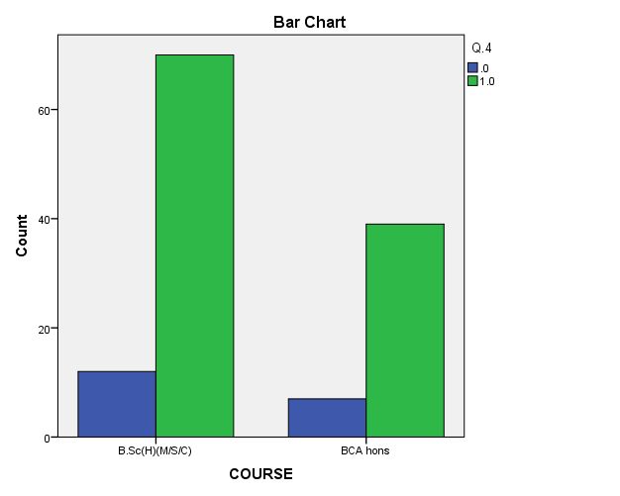

FIG7.5.- CLASSIFICATION OF STUDENTS ON THE BASIS OF RESPONSES ON Q4

**TABLE7. 7– CLASSIFICATION OF STUDENTS ON THE BASIS OF RESPONSES ON Q5**

(Q5 Are you satisfied with Co-curricular / Elective courses introduced in UG program

1-YES

0-NO

**Crosstab - COURSE * Q5**

|  |  |  |  |  |
| --- | --- | --- | --- | --- |
| Crosstab | | | | |
| Count | | | | |
|  | | Q.5 | | Total |
| .0 | 1.0 |
| COURSE | B.Sc(H)(M/S/C) | 11 | 71 | 82 |
| BCA hons | 5 | 41 | 46 |
| Total | | 16 | 112 | 128 |

From the above table it is observed that most of the students are In favor of Q5

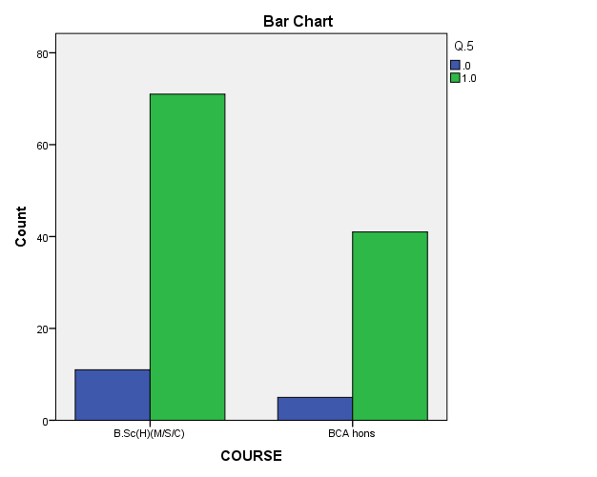

FIG 7.6- CLASSIFICATION OF STUDENTS ON THE BASIS OF RESPONSES ON Q5

**TABLE 7. 8 -CLASSIFICATION OF STUDENTS ON THE BASIS OF RESPONSES ON Q6**

(Q6 Do you agree with the policy statement that multiple entry/exit option in 4 years bachelors as a certificate in one year, diploma in 2 years, degree in 3 years while research in 4th year is beneficial for students

1-YES

0-NO

**CROSSTAB -COURSE * Q.6**

|  |  |  |  |  |
| --- | --- | --- | --- | --- |
| Crosstab | | | | |
| Count | | | | |
|  | | Q.6 | | Total |
| .0 | 1.0 |
| COURSE | B.Sc(H)(M/S/C) | 3 | 79 | 82 |
| BCA hons | 7 | 39 | 46 |
| Total | | 10 | 118 | 128 |

From the above table it is observed that most of the students are In favor of Q6

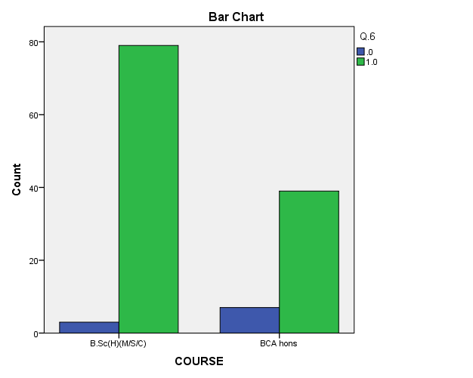

FIG 7.7- CLASSIFICATION OF STUDENTS ON THE BASIS OF RESPONSES ON Q6

**TABLE 7.9 – CLASSIFICATION OF STUDENTS ON THE BASIS OF RESPONSES ON Q7**

(Q7 Do you agree with the policy statement that multiple entry/exit option in UG courses will positively affect the education and career of students?

1-YES

0-NO

**CROSSTAB - COURSE * Q.7**

|  |  |  |  |  |
| --- | --- | --- | --- | --- |
| Crosstab | | | | |
| Count | | | | |
|  | | Q.7 | | Total |
| .0 | 1.0 |
| COURSE | B.Sc(H)(M/S/C) | 5 | 77 | 82 |
| BCA hons | 8 | 38 | 46 |
| Total | | 13 | 115 | 128 |

From the above table it is observed that most of the students are In favor of Q7

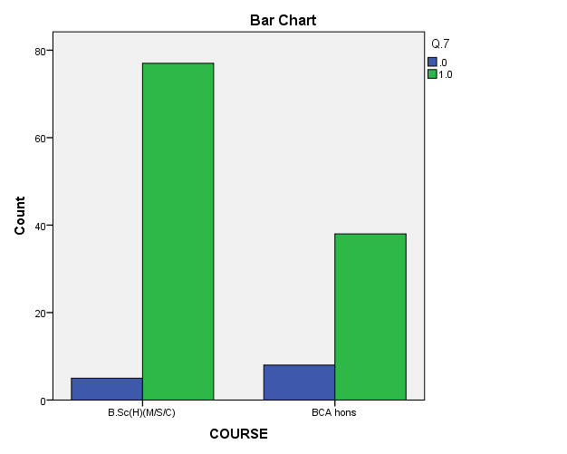

FIG7.8- CLASSIFICATION OF STUDENTS ON THE BASIS OF RESPONSES ON Q7

**TABLE 7.10 – CLASSIFICATION OF STUDENTS ON THE BASIS OF RESPONSES ON Q8**

(Q8 Do you want that the method of teaching in institutions need to be reinvent?

1-YES

0-NO

**CROSSTAB - COURSE * Q.8**

|  |  |  |  |  |
| --- | --- | --- | --- | --- |
| Crosstab | | | | |
| Count | | | | |
|  | | Q.8 | | Total |
| .0 | 1.0 |
| COURSE | B.Sc(H)(M/S/C) | 11 | 71 | 82 |
| BCA hons | 5 | 41 | 46 |
| Total | | 16 | 112 | 128 |

From the above table it is observed that most of the students are In favor of Q8

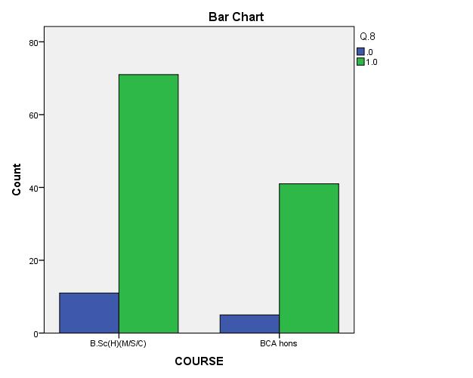

FIG 7.9- CLASSIFICATION OF STUDENTS ON THE BASIS OF RESPONSES ON Q8

**TABLE 7.11 – CLASSIFICATION OF STUDENTS ON THE BASIS OF RESPONSES ON Q9**

Q9 Theoretical syllabus of course is a burden and reason of stress for students. Do you think that Reduction in the syllabus to core essentials with experimental learning and critical thinking will lessen the burden on students for gaining a higher percentage of marks and reduce mishaps due to stress of studies?

1-YES

0-NO

**CROSSTAB -COURSE * Q.9**

|  |  |  |  |  |
| --- | --- | --- | --- | --- |
| Crosstab | | | | |
| Count | | | | |
|  | | Q.9 | | Total |
| .0 | 1.0 |
| COURSE | B.Sc(H)(M/S/C) | 7 | 75 | 82 |
| BCA hons | 4 | 42 | 46 |
| Total | | 11 | 117 | 128 |

From the above table it is observed that most of the students are In favor of Q9

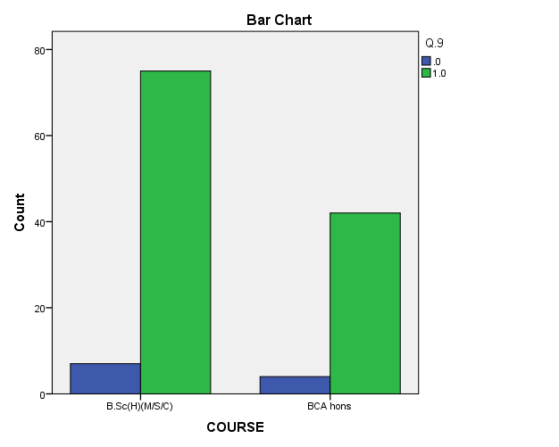

FIG7.10- CLASSIFICATION OF STUDENTS ON THE BASIS OF RESPONSES ON Q9

**TABLE 7. 12– CLASSIFICATION OF STUDENTS ON THE BASIS OF RESPONSES ON Q10**

Q10 Do you think that STEAM (Science, Technology, Engineering, Art, Mathematics) is better than the previous STEM (Science , Technology, Engineering, Mathematics) model in higher education at UG level?

1-YES

0-NO

**CROSSTAB -COURSE * Q.10**

|  |  |  |  |  |
| --- | --- | --- | --- | --- |
| Crosstab | | | | |
| Count | | | | |
|  | | Q.10 | | Total |
| .0 | 1.0 |
| COURSE | B.Sc(H)(M/S/C) | 9 | 73 | 82 |
| BCA hons | 6 | 40 | 46 |
| Total | | 15 | 113 | 128 |
|  | |  |  |  |

From the above table it is observed that most of the students are In favor of Q10

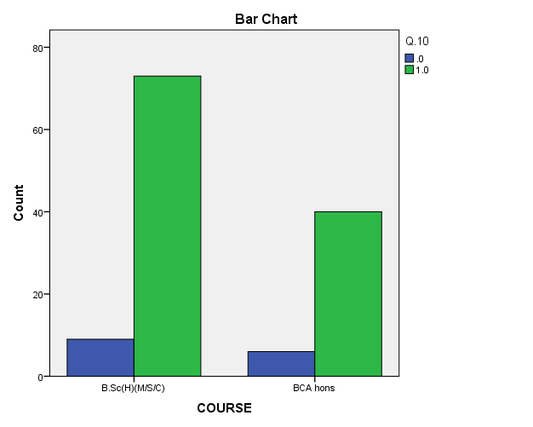

FIG 7.11- CLASSIFICATION OF STUDENTS ON THE BASIS OF RESPONSES ON Q10

**TABLE 7. 13– CLASSIFICATION OF STUDENTS ON THE BASIS OF RESPONSES ON Q11**

Q3 Do you think that the concepts of elective paper/ co- curricular courses will beneficiary to you?

SA-STRONGLY AGREE

A-AGREE

SD-STRONGLY DISAGREE

D-DISAGREE

N-NEITHER AGREE NOR DISAGREE

**CROSSTAB -COURSE * Q.11**

|  |  |  |  |  |  |  |
| --- | --- | --- | --- | --- | --- | --- |
| Crosstab | | | | | | |
| Count | | | | | | |
|  | | Q.11 | | | | Total |
| A | D | N | SA |
| COURSE | B.Sc(H)(M/S/C) | 44 | 5 | 7 | 26 | 82 |
| BCA hons | 25 | 5 | 3 | 13 | 46 |
| Total | | 69 | 10 | 10 | 39 | 128 |

From the above table it is observed that most of the students are In favor of Q11

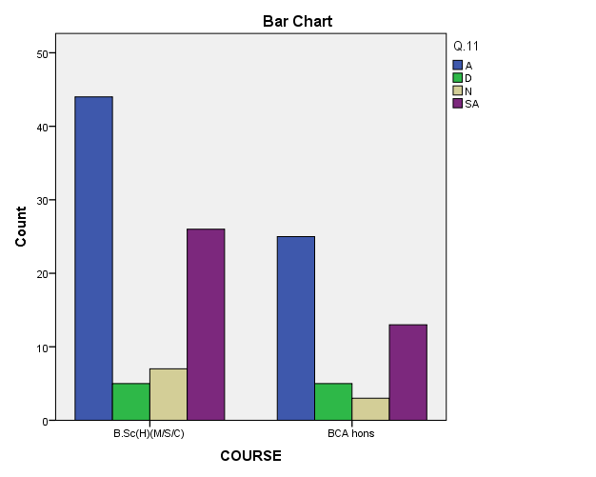

FIG7.12- CLASSIFICATION OF STUDENTS ON THE BASIS OF RESPONSES ON Q11

**TABLE 7. 14– CLASSIFICATION OF STUDENTS ON THE BASIS OF RESPONSES ON Q12**

(Q3 Do you think that jobs after vocational courses should be assured by the government to boost employment situation?)

SA-STRONGLY AGREE

A-AGREE

SD-STRONGLY DISAGREE

D-DISAGREE

N-NEITHER AGREE NOR DISAGREE

**CROSSTAB - COURSE * Q.12**

|  |  |  |  |  |  |  |  |
| --- | --- | --- | --- | --- | --- | --- | --- |
| Crosstab | | | | | | | |
| Count | | | | | | | |
|  | | Q.12 | | | | | Total |
| A | D | N | SA | SD |
| COURSE | B.Sc(H)(M/S/C) | 45 | 4 | 15 | 17 | 1 | 82 |
| BCA hons | 27 | 3 | 4 | 12 | 0 | 46 |
| Total | | 72 | 7 | 19 | 29 | 1 | 128 |

From the above table it is observed that most of the students are In favor of Q12

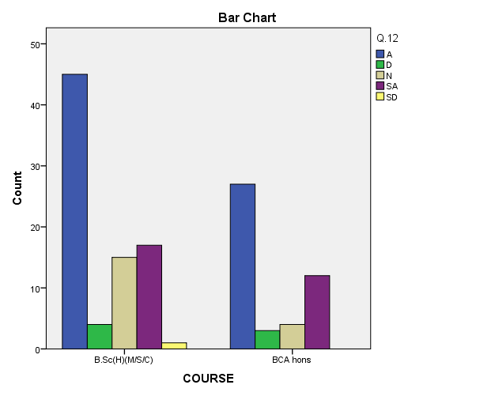

FIG7.13- CLASSIFICATION OF STUDENTS ON THE BASIS OF RESPONSES ON Q12

**TABLE 1.15 – CLASSIFICATION OF STUDENTS ON THE BASIS OF RESPONSES ON Q13**

(Q13 As the Ministry of Education highlighted that the NEP policy is based on the pillars of “ access, equity, quality, affordability, accountability” and will transform India into a “vibrant knowledge Hub” Do you agree with this fact?

SA-STRONGLY AGREE

A-AGREE

SD-STRONGLY DISAGREE

D-DISAGREE

N-NEITHER AGREE NOR DISAGREE

**CROSSTAB - COURSE * Q.13**

|  |  |  |  |  |  |  |  |
| --- | --- | --- | --- | --- | --- | --- | --- |
| Crosstab | | | | | | | |
| Count | | | | | | | |
|  | | Q.13 | | | | | Total |
| A | D | N | SA | SD |
| COURSE | B.Sc(H)(M/S/C) | 49 | 8 | 7 | 17 | 1 | 82 |
| BCA hons | 30 | 3 | 2 | 11 | 0 | 46 |
| Total | | 79 | 11 | 9 | 28 | 1 | 128 |

From the above table it is observed that most of the students are In favor of Q13

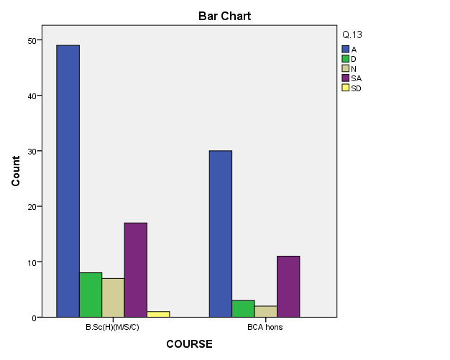

FIG7.14- CLASSIFICATION OF STUDENTS ON THE BASIS OF RESPONSES ON Q13

**TABLE 1.16 – CLASSIFICATION OF STUDENTS ON THE BASIS OF RESPONSES ON Q14**

Q3 The aim of NEP- 2020 to increase the Gross Enrolment Ratio in higher education including vocational education from 26.3% (2018) to 50% by 2035. Do you think that the increment in gross enrolment ratio will help to improve the level of literacy in India?

SA-STRONGLY AGREE

A-AGREE

SD-STRONGLY DISAGREE

D-DISAGREE

N-NEITHER AGREE NOR DISAGREE

**CROSSTAB -COURSE * Q.14**

|  |  |  |  |  |  |  |  |
| --- | --- | --- | --- | --- | --- | --- | --- |
| Crosstab | | | | | | | |
| Count | | | | | | | |
|  | | Q.14 | | | | | Total |
| A | D | N | SA | SD |
| COURSE | B.Sc(H)(M/S/C) | 44 | 5 | 14 | 18 | 1 | 82 |
| BCA hons | 26 | 4 | 3 | 13 | 0 | 46 |
| Total | | 70 | 9 | 17 | 31 | 1 | 128 |

From the above table it is observed that most of the students are In favor of Q14

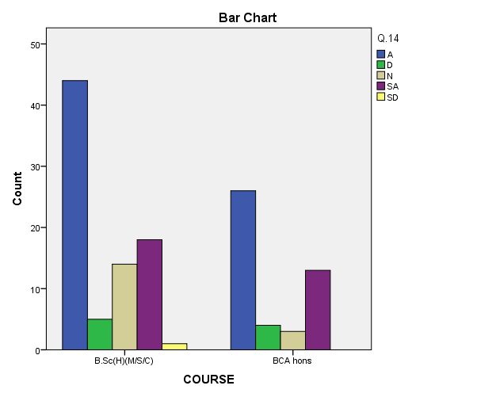

FIG7.15- CLASSIFICATION OF STUDENTS ON THE BASIS OF RESPONSES ON Q14

**TABLE 7.17 – CLASSIFICATION OF STUDENTS ON THE BASIS OF RESPONSES ON Q15**

Q15 Is there any change in current reforms that you did not want?

1-YES

0-NO

**CROSSTAB - COURSE * Q.15**

|  |  |  |  |  |
| --- | --- | --- | --- | --- |
| Crosstab | | | | |
| Count | | | | |
|  | | Q.15 | | Total |
| .0 | 1.0 |
| COURSE | B.Sc(H)(M/S/C) | 56 | 26 | 82 |
| BCA hons | 29 | 17 | 46 |
| Total | | 85 | 43 | 128 |

From the above table it is observed that most of the students are In favor of Q15

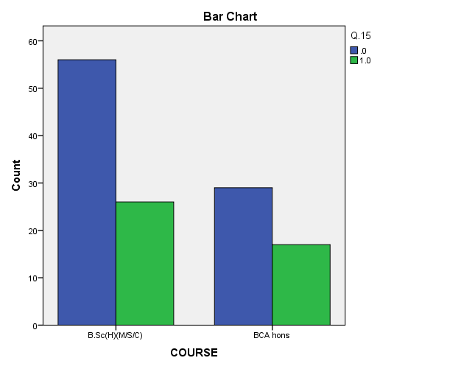

FIG-7.16 CLASSIFICATION OF STUDENTS ON THE BASIS OF RESPONSES ON Q15

**TESTING OF HYPOTHESIS-**

1.Are you awake about recent switches made by the Indian government in the education system of India.

**HYPOTHESIS**

* H0(p>0.05): (null hypothesis) The two variables are independent.
* H1(p<0.05): (alternative hypothesis) The two variables are not independent.

**TABLE 7.17- VALUE OF CHI SQUARES**

|  |  |  |  |  |  |
| --- | --- | --- | --- | --- | --- |
| Chi-Square Tests | | | | | |
|  | Value | Df | Asymp. Sig. (2-sided) | Exact Sig. (2-sided) | Exact Sig. (1-sided) |
| Pearson Chi-Square | .170a | 1 | .680 | .800 | .431 |
| Continuity Correctionb | .025 | 1 | .874 |  |  |
| Likelihood Ratio | .168 | 1 | .682 | .800 | .431 |
| Fisher's Exact Test |  |  |  | .800 | .431 |
| N of Valid Cases | 128 |  |  |  |  |
| a. 0 cells (0.0%) have expected count less than 5. The minimum expected count is 7.19. | | | | | |
| b. Computed only for a 2x2 table | | | | | |

We can see the p value for the test 0.800>0.05 The two-tailed p value is 0.800. Since this value is greater than 0.05, we fail to reject the null hypothesis. We do not have sufficient evidence to say that there is any statistically significant association between Q1 and course name.

1. First education policy was passed in 1968 followed by 1986 and further revised in 1992. Were you previously aware of this policy?

**HYPOTHESIS**

* H0(p>0.05): (null hypothesis) The two variables are independent.
* H1(p<0.05): (alternative hypothesis) The two variables are not independent.

**TABLE 7.18- VALUE OF CHI SQUARES**

|  |  |  |  |  |  |
| --- | --- | --- | --- | --- | --- |
| Chi-Square Tests | | | | | |
|  | Value | Df | Asymp. Sig. (2-sided) | Exact Sig. (2-sided) | Exact Sig. (1-sided) |
| Pearson Chi-Square | .553a | 1 | .457 | .572 | .291 |
| Continuity Correctionb | .308 | 1 | .579 |  |  |
| Likelihood Ratio | .556 | 1 | .456 | .572 | .291 |
| Fisher's Exact Test |  |  |  | .572 | .291 |
| N of Valid Cases | 128 |  |  |  |  |
| a. 0 cells (0.0%) have expected count less than 5. The minimum expected count is 17.97. | | | | | |
| b. Computed only for a 2x2 table | | | | | |

We can see the p value for the test 0.572>0.05 The two-tailed p value is 0.572. Since this value is greater than 0.05, we fail to reject the null hypothesis. We do not have sufficient evidence to say that there is any statistically significant association between Q2 and course name.

1. Online and offline platforms are available for students to gain knowledge. NEP-2020 is supporting online education. Are you comfortable with online learning?

**HYPOTHESIS**

* H0(p>0.05): (null hypothesis) The two variables are independent.
* H1(p<0.05): (alternative hypothesis) The two variables are not independent

.

**TABLE 7.19- VALUE OF CHI SQUARES**

|  |  |  |  |  |  |
| --- | --- | --- | --- | --- | --- |
| Chi-Square Tests | | | | | |
|  | Value | Df | Asymp. Sig. (2-sided) | Exact Sig. (2-sided) | Exact Sig. (1-sided) |
| Pearson Chi-Square | .051a | 1 | .822 | 1.000 | .503 |
| Continuity Correctionb | .000 | 1 | 1.000 |  |  |
| Likelihood Ratio | .050 | 1 | .822 | 1.000 | .503 |
| Fisher's Exact Test |  |  |  | .809 | .503 |
| N of Valid Cases | 128 |  |  |  |  |
| a. 0 cells (0.0%) have expected count less than 5. The minimum expected count is 7.55. | | | | | |
| b. Computed only for a 2x2 table | | | | | |

We can see the p value for the test 0.809>0.05 The two-tailed p value is 0.809. Since this value is greater than 0.05, we fail to reject the null hypothesis. We do not have sufficient evidence to say that there is any statistically significant association between Q3 and course name.

1. Are you satisfied with the elective papers/ Internship courses/ Field Projects introduced in PG program?

**HYPOTHESIS**

* H0(p>0.05): (null hypothesis) The two variables are independent.
* H1(p<0.05): (alternative hypothesis) The two variables are not independent.

**TABLE 7.20- VALUE OF CHI SQUARES**

|  |  |  |  |  |  |
| --- | --- | --- | --- | --- | --- |
| Chi-Square Tests | | | | | |
|  | Value | Df | Asymp. Sig. (2-sided) | Exact Sig. (2-sided) | Exact Sig. (1-sided) |
| Pearson Chi-Square | .008a | 1 | .929 | 1.000 | .561 |
| Continuity Correctionb | .000 | 1 | 1.000 |  |  |
| Likelihood Ratio | .008 | 1 | .929 | 1.000 | .561 |
| Fisher's Exact Test |  |  |  | 1.000 | .561 |
| N of Valid Cases | 128 |  |  |  |  |
| a. 0 cells (0.0%) have expected count less than 5. The minimum expected count is 6.83. | | | | | |
| b. Computed only for a 2x2 table  **We can see the p value for the test 1.000>0.05 The two-tailed p value is 1.000. Since this value is greater than 0.05, we fail to reject the null hypothesis. We do not have sufficient evidence to say that there is any statistically significant association between Q4 and course name** | | | | | |

1. Are you satisfied with Co-curricular / Elective courses introduced in UG program

**HYPOTHESIS**

* H0(p>0.05): (null hypothesis) The two variables are independent.
* H1(p<0.05): (alternative hypothesis) The two variables are not independent.

**TABLE7. 21- VALUE OF CHI SQUARES**

|  |  |  |  |  |  |
| --- | --- | --- | --- | --- | --- |
| Chi-Square Tests | | | | | |
|  | Value | Df | Asymp. Sig. (2-sided) | Exact Sig. (2-sided) | Exact Sig. (1-sided) |
| Pearson Chi-Square | .175a | 1 | .676 | .785 | .453 |
| Continuity Correctionb | .019 | 1 | .889 |  |  |
| Likelihood Ratio | .178 | 1 | .673 | .785 | .453 |
| Fisher's Exact Test |  |  |  | .785 | .453 |
| N of Valid Cases | 128 |  |  |  |  |
| a. 0 cells (0.0%) have expected count less than 5. The minimum expected count is 5.75. | | | | | |
| b. Computed only for a 2x2 table | | | | | |

We can see the p value for the test 0.785>0.05 The two-tailed p value is 0.785. Since this value is greater than 0.05, we fail to reject the null hypothesis. We do not have sufficient evidence to say that there is any statistically significant association between Q5 and course name.

**.**

1. Do you agree with the policy statement that multiple entry/exit option in 4 years bachelors as a certificate in one year, diploma in 2 years, degree in 3 years while research in 4th year is beneficial for students

**HYPOTHESIS**

* H0(p>0.05): (null hypothesis) The two variables are independent.
* H1(p<0.05): (alternative hypothesis) The two variables are not independent.

**TABLE 7.22- VALUE OF CHI SQUARES**

|  |  |  |  |  |  |
| --- | --- | --- | --- | --- | --- |
| Chi-Square Tests | | | | | |
|  | Value | df | Asymp. Sig. (2-sided) | Exact Sig. (2-sided) | Exact Sig. (1-sided) |
| Pearson Chi-Square | 5.467a | 1 | .019 | .035 | .025 |
| Continuity Correctionb | 3.980 | 1 | .046 |  |  |
| Likelihood Ratio | 5.214 | 1 | .022 | .035 | .025 |
| Fisher's Exact Test |  |  |  | .035 | .025 |
| N of Valid Cases | 128 |  |  |  |  |
| a. 1 cells (25.0%) have expected count less than 5. The minimum expected count is 3.59. | | | | | |
| b. Computed only for a 2x2 table | | | | | |
|  | | | | | |
|  | | | | | |

We can see the p value for the test 0.035<0.05 The two-tailed p value is 0.035. Since this value is less than 0.05, we reject the null hypothesis. We can say that there is significant association between Q6 and course name.

1. Do you agree with the policy statement that multiple entry/exit option in UG courses will positively affect the education and career of students?

HYPOTHESIS

* H0(p>0.05): (null hypothesis) The two variables are independent.
* H1(p<0.05): (alternative hypothesis) The two variables are not independent.

**TABLE 7.23 VALUE OF CHI SQUARES**

|  |  |  |  |  |  |
| --- | --- | --- | --- | --- | --- |
| Chi-Square Tests | | | | | |
|  | Value | Df | Asymp. Sig. (2-sided) | Exact Sig. (2-sided) | Exact Sig. (1-sided) |
| Pearson Chi-Square | 4.119a | 1 | .042 | .065 | .045 |
| Continuity Correctionb | 2.975 | 1 | .085 |  |  |
| Likelihood Ratio | 3.928 | 1 | .047 | .065 | .045 |
| Fisher's Exact Test |  |  |  | .065 | .045 |
| N of Valid Cases | 128 |  |  |  |  |
| a. 1 cells (25.0%) have expected count less than 5. The minimum expected count is 4.67. | | | | | |
| b. Computed only for a 2x2 table | | | | | |

We can see the p value for the test 0.065>0.05 The two-tailed p value is 0.065. Since this value is greater than 0.05, we fail to reject the null hypothesis. We do not have sufficient evidence to say that there is any statistically significant association between Q7 and course name.

.

1. Do you think that the methodology of teaching in higher education institutions needed to be reinvent ?

HYPOTHESIS

* H0(p>0.05): (null hypothesis) The two variables are independent.
* H1(p<0.05): (alternative hypothesis) The two variables are not independent.

**TABLE 7.24- VALUE OF CHI SQUARES**

|  |  |  |  |  |  |
| --- | --- | --- | --- | --- | --- |
| Chi-Square Tests | | | | | |
|  | Value | Df | Asymp. Sig. (2-sided) | Exact Sig. (2-sided) | Exact Sig. (1-sided) |
| Pearson Chi-Square | .175a | 1 | .676 | .785 | .453 |
| Continuity Correctionb | .019 | 1 | .889 |  |  |
| Likelihood Ratio | .178 | 1 | .673 | .785 | .453 |
| Fisher's Exact Test |  |  |  | .785 | .453 |
| N of Valid Cases | 128 |  |  |  |  |
| a. 0 cells (0.0%) have expected count less than 5. The minimum expected count is 5.75. | | | | | |
| b. Computed only for a 2x2 table | | | | | |

We can see the p value for the test 0.785>0.05 The two-tailed p value is 0.785 Since this value is greater than 0.05, we fail to reject the null hypothesis. We do not have sufficient evidence to say that there is any statistically significant association between Q8 and course name.

1. Reduction in the syllabus to core essentials with experimental learning and critical thinking will lessen the burden on students for gaining a higher percentage of marks and reduce mishaps due to stress of studies?

HYPOTHESIS

* H0(p>0.05): (null hypothesis) The two variables are independent.
* H1(p<0.05): (alternative hypothesis) The two variables are not independent.

**TABLE 7.25- VALUE OF CHI SQUARES**

|  |  |  |  |  |  |
| --- | --- | --- | --- | --- | --- |
| Chi-Square Tests | | | | | |
|  | Value | Df | Asymp. Sig. (2-sided) | Exact Sig. (2-sided) | Exact Sig. (1-sided) |
| Pearson Chi-Square | .001a | 1 | .975 | 1.000 | .607 |
| Continuity Correctionb | .000 | 1 | 1.000 |  |  |
| Likelihood Ratio | .001 | 1 | .975 | 1.000 | .607 |
| Fisher's Exact Test |  |  |  | 1.000 | .607 |
| N of Valid Cases | 128 |  |  |  |  |
| a. 1 cells (25.0%) have expected count less than 5. The minimum expected count is 3.95. | | | | | |
| b. Computed only for a 2x2 table | | | | | |

We can see the p value for the test 1.000>0.05 The two-tailed p value is 1.000. Since this value is greater than 0.05, we fail to reject the null hypothesis. We do not have sufficient evidence to say that there is any statistically significant association between Q9 and course name.

1. Whether do you think that STEAM (Science, Technology, Engineering, Art, Mathematics) is better than the previous STEM (Science , Technology, Engineering, Mathematics) model in higher education at a bachelor’s degree level?

HYPOTHESIS

* H0(p>0.05): (null hypothesis) The two variables are independent.
* H1(p<0.05): (alternative hypothesis) The two variables are not independent.

**TABLE 7.26- VALUE OF CHI SQUARES**

|  |  |  |  |  |  |
| --- | --- | --- | --- | --- | --- |
| Chi-Square Tests | | | | | |
|  | Value | Df | Asymp. Sig. (2-sided) | Exact Sig. (2-sided) | Exact Sig. (1-sided) |
| Pearson Chi-Square | .122a | 1 | .727 | .778 | .467 |
| Continuity Correctionb | .004 | 1 | .950 |  |  |
| Likelihood Ratio | .120 | 1 | .729 | .778 | .467 |
| Fisher's Exact Test |  |  |  | .778 | .467 |
| N of Valid Cases | 128 |  |  |  |  |
| a. 0 cells (0.0%) have expected count less than 5. The minimum expected count is 5.39. | | | | | |
| b. Computed only for a 2x2 table | | | | | |

We can see the p value for the test 0.778>0.05 The two-tailed p value is 0.778. Since this value is greater than 0.05, we fail to reject the null hypothesis. We do not have sufficient evidence to say that there is any statistically significant association between Q10 and course name

1. Do you think that the concepts of elective paper/ co- curricular courses will beneficiary to you?

HYPOTHESIS

* H0(p>0.05): (null hypothesis) The two variables are independent.
* H1(p<0.05): (alternative hypothesis) The two variables are not independent.

**TABLE 7.27- VALUE OF CHI SQUARES**

|  |  |  |  |  |
| --- | --- | --- | --- | --- |
| Chi-Square Tests | | | | |
|  | Value | Df | Asymp. Sig. (2-sided) | Exact Sig. (2-sided) |
| Pearson Chi-Square | 1.130a | 3 | .770 | .799 |
| Likelihood Ratio | 1.100 | 3 | .777 | .799 |
| Fisher's Exact Test | 1.190 |  |  | .819 |
| N of Valid Cases | 128 |  |  |  |
| a. 2 cells (25.0%) have expected count less than 5. The minimum expected count is 3.59. | | | | |

We can see the p value for the test 0.819>0.05 The two-tailed p value is 0.819. Since this value is greater than 0.05, we fail to reject the null hypothesis. We do not have sufficient evidence to say that there is any statistically significant association between Q11 and course name.

.

1. Do you think that jobs after vocational courses should be assured by the government to boost employment situation?

HYPOTHESIS

* H0(p>0.05): (null hypothesis) The two variables are independent.
* H1(p<0.05): (alternative hypothesis) The two variables are not independent.

**TABLE 7.28- VALUE OF CHI SQUARES**

|  |  |  |  |  |
| --- | --- | --- | --- | --- |
| Chi-Square Tests | | | | |
|  | Value | Df | Asymp. Sig. (2-sided) | Exact Sig. (2-sided) |
| Pearson Chi-Square | 2.984a | 4 | .560 | .602 |
| Likelihood Ratio | 3.464 | 4 | .483 | .578 |
| Fisher's Exact Test | 3.039 |  |  | .581 |
| N of Valid Cases | 128 |  |  |  |
| a. 4 cells (40.0%) have expected count less than 5. The minimum expected count is .36. | | | | |

We can see the p value for the test 0.581>0.05 The two-tailed p value is 0.581. Since this value is greater than 0.05, we fail to reject the null hypothesis. We do not have sufficient evidence to say that there is any statistically significant association between Q12 and course name

1. As the Ministry of Education highlighted that the NEP policy is based on the pillars of “ access, equity, quality, affordability, accountability” and will transform India into a “vibrant knowledge Hub” Do you agree with this fact?

HYPOTHESIS

* H0(p>0.05): (null hypothesis) The two variables are independent.
* H1(p<0.05): (alternative hypothesis) The two variables are not independent.

**TABLE 7.29- VALUE OF CHI SQUARES**

|  |  |  |  |  |
| --- | --- | --- | --- | --- |
| Chi-Square Tests | | | | |
|  | Value | df | Asymp. Sig. (2-sided) | Exact Sig. (2-sided) |
| Pearson Chi-Square | 1.934a | 4 | .748 | .814 |
| Likelihood Ratio | 2.334 | 4 | .675 | .801 |
| Fisher's Exact Test | 1.758 |  |  | .849 |
| N of Valid Cases | 128 |  |  |  |
| a. 4 cells (40.0%) have expected count less than 5. The minimum expected count is .36. | | | | |

We can see the p value for the test 0.849>0.05 The two-tailed p value is 0.849. Since this value is greater than 0.05, we fail to reject the null hypothesis. We do not have sufficient evidence to say that there is any statistically significant association between Q13 and course name.

1. The aim of NEP- 2020 to increase the Gross Enrolment Ratio in higher education including vocational education from 26.3% (2018) to 50% by 2035. Do you think that the increment in gross enrolment ratio will help to improve the level of literacy in India?

**HYPOTHESIS**

* H0(p>0.05): (null hypothesis) The two variables are independent.
* H1(p<0.05): (alternative hypothesis) The two variables are not independent.

**TABLE 7.30- VALUE OF CHI SQUARES**

|  |  |  |  |  |
| --- | --- | --- | --- | --- |
| Chi-Square Tests | | | | |
|  | Value | df | Asymp. Sig. (2-sided) | Exact Sig. (2-sided) |
| Pearson Chi-Square | 3.843a | 4 | .428 | .429 |
| Likelihood Ratio | 4.449 | 4 | .349 | .402 |
| Fisher's Exact Test | 3.894 |  |  | .410 |
| N of Valid Cases | 128 |  |  |  |
| a. 3 cells (30.0%) have expected count less than 5. The minimum expected count is .36. | | | | |

We can see the p value for the test 0.410>0.05 The two-tailed p value is 0.410. Since this value is greater than 0.05, we fail to reject the null hypothesis. We do not have sufficient evidence to say that there is any statistically significant association between Q14 and course name.

1. Is there any change in current reforms that you did not want?

**HYPOTHESIS**

* H0(p>0.05): (null hypothesis) The two variables are independent.
* H1(p<0.05): (alternative hypothesis) The two variables are not independent.

**TABLE 7.31- VALUE OF CHI SQUARES**

|  |  |  |  |  |  |
| --- | --- | --- | --- | --- | --- |
| Chi-Square Tests | | | | | |
|  | Value | Df | Asymp. Sig. (2-sided) | Exact Sig. (2-sided) | Exact Sig. (1-sided) |
| Pearson Chi-Square | .364a | 1 | .546 | .564 | .340 |
| Continuity Correctionb | .167 | 1 | .683 |  |  |
| Likelihood Ratio | .362 | 1 | .548 | .564 | .340 |
| Fisher's Exact Test |  |  |  | .564 | .340 |
| N of Valid Cases | 128 |  |  |  |  |
| a. 0 cells (0.0%) have expected count less than 5. The minimum expected count is 15.45. | | | | | |
| b. Computed only for a 2x2 table | | | | | |

We can see the p value for the test 0.564>0.05 The two-tailed p value is 0.564. Since this value is greater than 0.05, we fail to reject the null hypothesis. We do not have sufficient evidence to say that there is any statistically significant association between Q15 and course name.

**SUMMARY REPORT**

A revamped education system integrating a flexible, multidisciplinary curriculum coupled with a conscious inclusion of life skills had been long overdue, up until January 2023.. The purpose of the National Education Policy is to develop students’ in critical thinking skills, scientific temper, and imagination, along with instilling values like empathy, courage, and resilience. This paper endeavors to introduce you to the key aspects of the novel National Education Policy (here on referred to as the NEP), discuss its pros and cons, and offer solutions and recommendations to potential problems observed.

With the 20th century marked as the computer era, the digital age is spreading its wings and is also posing challenges of management perspectives to deal with its growing needs. Education System is the one most neglected part because of it being a major challenge for developing countries like India. Many intellectual minds are on work to amend the prevalent and adapted education system having roots in 1980s. In a layman language NEP, 2020 is updating of education system from traditional concept of 1980s to 21st century to adapt and accept changes with advancing technology. Although we have been upgraded in almost all sectors, whether telecommunication or transportation but the most needed and basic of any advancement is through education which still lags behind. To analyze the opinion of students and about new education policy one survey was conducted at “**Bundelkhand University”**  by “**Department Of Mathematical Science and Computer Applications”**. It was responded by a total of 128 respondents, the major populations involved was of Science and technical stream students children. The results were promising and suggestive for implementation of NEP, 2020. With the advent in technology the importance of education was clearly emphasized along with the pros and cons of NEP policy. The results reveal the loopholes and positive aspects of education system prevalent till now and crux of NEP, 2020. The basic infrastructure in India being a developing country needs to be furnished by government before implementing any policy on mass scale to avoid any hustle as education is milestone in deciding future of youth and any country’s economic growth.

|  |  |  |  |  |  |  |  |  |  |  |  |  |  |  |  |  |  |  |  |  |  |  |  |  |  |  |  |  |  |
| --- | --- | --- | --- | --- | --- | --- | --- | --- | --- | --- | --- | --- | --- | --- | --- | --- | --- | --- | --- | --- | --- | --- | --- | --- | --- | --- | --- | --- | --- |
| |  | | --- | | **COMPARISON ON THE AWARENESS OF NATIONAL EDUCATION POLICY 2020 AND**  **NATIONAL EDUCATION POLICY 1986** | | | | | | | | | | | | | | | | | | | | | | | | | | | | | |
|  | | | | **Analysis of the AWARENESS OF NATIONAL EDUCATION POLICY 2020** | | | | | | | | | | | | |  | | | | |  |  | |
|  | | |  | | --- | |  | | | |  | |  | |  | | |  | | |  | | |  | |  | | | | | |  |  |
|  | | Q.1 | | | | | | | | | | | | | | | |  | |  | | | | | |  |  |
|  | |  | | | | | Frequency | | Percent | | | Valid Percent | | | Cumulative Percent | | |  | |  | | | | | |  |  |
|  | | Valid | | | .0 | | 20 | | 15.6 | | | 15.6 | | | 15.6 | | |  | |  | | | | | |  |  |
|  | | 1.0 | | 108 | | 84.4 | | | 84.4 | | | 100.0 | | |  | |  | | | | | |  |  |
|  | | Total | | 128 | | 100.0 | | | 100.0 | | |  | | |  | |  | | | | | |  |  |
| |  | | --- | |  | | |  | | |  | |  | |  | | |  | | |  | | |  | |  | | | | | |  |  |
|  | |  | | |  | |  | |  | | |  | | |  | | |  | |  | | | | | |  |  |
|  | |  | | |  | |  | |  | | |  | | |  | | |  | |  | | | | | |  |  |
|  | |  | | |  | |  | |  | | |  | | |  | | |  | |  | | | | | |  |  |
|  | |  | | |  | |  | |  | | |  | | |  | | |  | |  | | | | | |  |  |
|  | |  | | |  | |  | |  | | |  | | |  | | |  | |  | | | | | |  |  |
|  | |  | | |  | |  | |  | | |  | | |  | | |  | |  | | | | | |  |  |
|  | |  | | |  | |  | |  | | |  | | |  | | |  | |  | | | | | |  |  |
|  | |  | | |  | |  | |  | | |  | | |  | | |  | |  | | | | | |  |  |
|  | |  | | |  | |  | |  | | |  | | |  | | |  | |  | | | | | |  |  |
|  | |  | | |  | |  | |  | | |  | | |  | | |  | |  | | | | | |  |  |
|  | |  | | |  | |  | |  | | |  | | |  | | |  | |  | | | | | |  |  |
|  | |  | | |  | |  | |  | | |  | | |  | | |  | |  | | | | | |  |  |
|  | |  | | |  | |  | |  | | |  | | |  | | |  | |  | | | | | |  |  |
|  | |  | | |  | |  | |  | | |  | | |  | | |  | |  | | | | | |  |  |
|  | |  | | |  | |  | |  | | |  | | |  | | |  | |  | | | | | |  |  |
|  | |  | | |  | |  | |  | | |  | | |  | | |  | |  | | | | | |  |  |
|  | |  | | |  | |  | |  | | |  | | |  | | |  | |  | | | | | |  |  |
|  | |  | | |  | |  | |  | | |  | | |  | | |  | |  | | | | | |  |  |
|  | |  | | |  | |  | |  | | |  | | |  | | |  | |  | | | | | |  |  |
|  | |  | | |  | |  | |  | | |  | | |  | | |  | |  | | | | | |  |  |
|  | |  | | |  | |  | |  | | |  | | | |  |  |  | | --- | --- | --- | | FIG – 7.17 | FIG7.17 |  | | | |  | |  | | | | | |  |  |
|  | |  | | |  | |  | |  | | |  | | |  | | |  | |  | | | | | |  |  |
|  | |  | | |  | |  | |  | | |  | | |  | | |  | |  | | | | | |  |  |
|  | |  | | |  | |  | |  | | |  | | |  | | |  | |  | | | | | |  |  |
|  | |  | | |  | |  | |  | | |  | | |  | | |  | |  | | | | | |  |  |
| RESULT- APPROXIMATELY 84.38% STUDENTS ARE AWARE ABOUT THE NEW AMENDMENTS IN NATIONAL EDUCTAION POLICY 2020 | |  | | |  | |  | |  | | |  | | |  | | |  | |  | | | | | |  |  |
|  | |  | | |  | |  | |  | | |  | | |  | | |  | |  | | | | | |  |  |
|  | |  | | |  | |  | |  | | |  | | |  | | |  | |  | | | | | |  |  |
| **Analysis of the AWARENESS OF NATIONAL EDUCATION POLICY 1996** | | | | | | | | | | | | |  | |  | | |  | |  | | |
|  | | |  | | --- | |  | | | |  | |  | |  |  | |  |  | |  | | |  | |  | | |
| **Q.2** First education policy was passed in 1968 followed by 1986 and further revised in 1992. Were you previously aware of this policy? | | | | | | | | | | | |  |  | |  | | |  | |  | | |
|  | | | | | Frequency | | Percent | | Valid Percent | Cumulative Percent | |  |  | |  | | |  | |  | | |
| Valid | | .0 | | | 50 | | 39.1 | | 39.1 | 39.1 | |  |  | |  | | |  | |  | | |
| 1.0 | | | 78 | | 60.9 | | 60.9 | 100.0 | |  |  | |  | | |  | |  | | |
| Total | | | 128 | | 100.0 | | 100.0 |  | |  |  | |  | | |  | |  | | |
|  | |  | | |  | |  | |  |  | |  |  | |  | | |  | |  | | |
| |  | | --- | |  | | |  | | |  | |  | |  |  | |  |  | |  | | |  | |  | | |
|  | |  | | |  | |  | |  |  | |  |  | |  | | |  | |  | | |
|  | |  | | |  | |  | |  |  | |  |  | |  | | |  | |  | | |
|  | |  | | |  | |  | |  |  | |  |  | |  | | |  | |  | | |
|  | |  | | |  | |  | |  |  | |  |  | |  | | |  | |  | | |
|  | |  | | |  | |  | |  |  | |  |  | |  | | |  | |  | | |
|  | |  | | |  | |  | |  |  | |  |  | |  | | |  | |  | | |
|  | |  | | |  | |  | |  |  | |  |  | |  | | |  | |  | | |
|  | |  | | |  | |  | |  |  | |  |  | |  | | |  | |  | | |
|  | |  | | |  | |  | |  |  | |  |  | |  | | |  | |  | | |
|  | |  | | |  | |  | |  |  | |  |  | |  | | |  | |  | | |
|  | |  | | |  | |  | |  |  | |  |  | |  | | |  | |  | | |
|  | |  | | |  | |  | |  |  | |  |  | |  | | |  | |  | | |
|  | |  | | |  | |  | |  |  | |  |  | |  | | |  | |  | | |
|  | |  | | |  | |  | |  |  | |  |  | |  | | |  | |  | | |
|  | |  | | |  | |  | |  |  | |  |  | |  | | |  | |  | | |
|  | |  | | |  | |  | |  |  | |  |  | |  | | |  | |  | | |
|  | |  | | |  | |  | |  |  | |  |  | |  | | |  | |  | | |
|  | |  | | |  | |  | |  |  | |  |  | |  | | |  | |  | | |
|  | |  | | |  | |  | |  |  | |  |  | |  | | |  | |  | | |
|  | |  | | |  | |  | |  |  | | |  |  | | --- | --- | | FIG7.18 |  | |  | |  | | |  | |  | | |
|  | |  | | |  | |  | |  |  | |  |  | |  | | |  | |  | | |
|  | |  | | |  | |  | |  |  | |  |  | |  | | |  | |  | | |
|  | |  | | |  | |  | |  |  | |  |  | |  | | |  | |  | | |
| RESULT- APPROXIMATELY 60.94% STUDENTS ARE AWARE ABOUT THE PREVIOUS NATIONAL POLICY AMENDMENTS , AMENDED IN 1992,1986, 1968. | |  | | |  | |  | |  |  | |  |  | |  | | |  | |  | | |
|  | |  | | |  | |  | |  |  | |  |  | |  | | |  | |  | | |

**CHAPTER – 8 RESULT AND CONCLUSION**

**RESULT-**

The survey entitled “STATISTICAL SURVEY ON AWARENESS AND IMPACT OF NATIONAL EDUCATION POLICY -2020” was conducted college going students of BUNDELKHAND UNIVERSITY. It was conducted in a MCQ based format and 15 questions were asked from the audience and 128 responses were obtained.

* RESULT- APPROXIMATELY 84.38% STUDENTS ARE AWARE ABOUT THE NEW AMENDMENTS IN NATIONAL EDUCTAION POLICY 2020
* RESULT- APPROXIMATELY 60.94% STUDENTS ARE AWARE ABOUT THE PREVIOUS NATIONAL POLICY AMENDMENTS , AMENDED IN 1992,1986, 1968.

**AMENDEMENTS PROVIDED BY STUDENTS-**

|  |
| --- |
| 1. 75 percentage Attendance should not be mandatory |
| 1. The government should make the education system like there should be knowledge of every subject but to master in one single subject .The syllabus should be remake to what is needed in the future ,what is beneficial ,no any stupid shit should be in the books that are provided to children |
| 1. I want that there should also be the course of teaching UG student for internship. |
| 1. Digital classes |
| 1. not being promoted due to lack of credit |
| 1. Yes it is compulsary to boost education system Because this education system very effected to all students |
| 1. Well the overall structure is only changed the methods of teaching and the way students and teachers interact hasn't changed yet we need to change the subjects and the way of teaching as well. |
| 1. Literacy |
| 1. It's good |

##### **CONCLUSION-** National Education Policy of India 2020 is marching towards achieving such objective by making innovative policies to improve the quality, attractiveness, affordability, and increasing the supply by opening up the higher education for the private sector and at the same time with strict controls to maintain quality in every higher education institution. By encouraging merit-based admissions with free-ships & scholarships, merit & research based continuous performers as faculty members, and merit based proven leaders in regulating bodies, and strict monitoring of quality through biennial accreditation based on self-declaration of progress through technology-based monitoring, NEP-2020 is expected to fulfill its objectives by 2030. HE system will transform itself as student centric with the freedom to choose core and allied subjects within a discipline and across disciplines. Faculty members also get autonomy to choose curriculum, methodology, pedagogy and evaluation models within the given policy framework. These transformations will start from the academic year 2021-22 and will continue until the year 2030 where the first level of transformation is expected to visible. Hence, the Indian higher education system is moving from teacher centric to student centric, information centric to knowledge centric, marks centric to skills centric, examination centric to experimental centric, learning centric to research centric, and choice centric to competency centric. As of 2022, India has over 1000 universities, with a break up of 54 central universities, 416 state universities, 125 deemed universities, 361 private universities and 159 Institutes of National Importance which include AIIMS, IIMs, IIITs, IISERs, IITs and NITs among others.After reshuffle of present government, the new education minister has clearly focused his agenda to implement NEP as top priority although the implementation process is half done through conferences and meetings onNEP, 2020. The article was successful in gauging opinion of people sitting in education sectors regarding NEP,2020 and was also able to spread awareness to a set of population as 128 participants were actively engaged in furnishing the survey. In first aspect the ministry needs to set review committee that will be headed by higher education Department officials. Almost academic schedules which have been disturbed due to Covid- 19 need to be addressed and officiating dignitaries have to be invited on one platform to work out on flaws of NEP,2020. So, this way, NEP has to work on grassroots level to understand the basic infrastructure prevailing in India being a developing country. We can’t jump directly to decisions and implement new policy in days or years. It takes long time to establish particular trend in cultural traditional India.

**REFERENCES**

* https://ruralindiaonline.org/en/library/resource/national-education-policy-2020/?gclid=EAIaIQobChMIv6WliZzs_AIV7tpMAh00dAHHEAAYASAAEgJNSPD_BwE
* sdmmmkmysore.in/department/commerce/shubhada/new%20education%20policy%202020-a%20comparative%20analysis%20with%20existing%20national%20policy%20of%20education%201986.pdf
* https://en.wikipedia.org/wiki/List_of_state_universities_in_India
* https://www.statsdirect.com/help/exact_tests_on_counts/fisher_exact.htm
* https://www.researchgate.net/publication/357660759_NEP2020-A_Review_cum_Survey_Based_Analysis_of_Myths_and_Reality_of_Education_in_India/link/61d87580da5d105e552507fd/download